
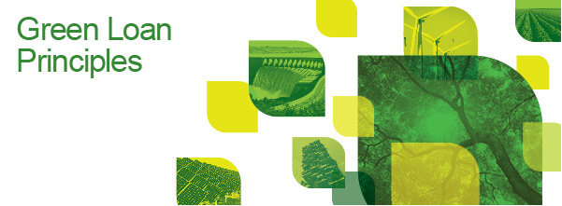
The LMA publishes Green Loan Principles

The LMA has, together with the APLMA, launched the Green Loan Principles (GLP) with the support of the International Capital Market Association (ICMA). The GLP aim to create a high-level framework of market standards and guidelines, providing a consistent methodology for use across the wholesale green loan market, whilst allowing the loan product to retain its flexibility, and preserving the integrity of the green loan market while it develops. The GLP build on and refer to the Green Bond Principles (GBP) of the ICMA, with a view to promoting consistency across financial markets.
The GLP were developed by a working party, consisting of representatives from leading financial institutions active in the green loan market, with the assistance of the Association of Corporate Treasurers, the International Capital Market Association and the European Banking Federation.
They set out a clear framework of recommendations, to be applied by market participants on a deal-by-deal basis depending on the underlying characteristics of the transaction, based around the following four core components:
1. Use of Proceeds
2. Process for Project Evaluation and Selection
3. Management of Proceeds
4. Reporting
The need for this project was originally identified in 2017 by the Global Green Finance Council (GGFC), of which the LMA and ICMA are both founder members, and the APLMA, which established a working group in June 2016.
The publication of the GLP marks the first step towards establishing widely accepted principles in the green lending space. Looking ahead, the working party will be seeking to expand the scope of the GLP to capture alternative models of green finance.
Commenting on the principles, Clare Dawson, Chief Executive of the LMA, said:
"This widely supported initiative marks an important first move towards establishing a framework for green lending across global wholesale markets. The LMA will continue to work with market participants and other trade bodies to expand the range of loan products that can follow the GLP and thereby provide an alternative way of funding to a wider range of borrowers."
Notes
The GGFC was created in 2017 with the objective to bring together key global and regional financial associations and other stakeholders involved in green and sustainable finance. The GGFC was founded by the Global Financial Market Association (GFMA), the International Capital Market Association (ICMA), the European Banking Federation (EBF), the European Covered Bond Council (EMF-ECBC), the Institute of International Finance (IIF), the Loan Market Association (LMA) and the World Federation of Exchanges. Other organisations are participating as observers, including CERES, the European Financial Roundtable (EFR) and InsuranceEurope.

